1. INTRODUCTION

1.1 OVER VIEW

The tableau on housing prices in metropolitan

areas of India is designed to get on idea for buying houses knowing the rates ,places ,location ,nearby locations ,and so on. It provides information to buyer to buy the house for their reasonable price. We can give solution to the people’s problem.

1.2 PURPOSE

It helps us to know our needings by go-throughing the tableau. We can get to know that how many houses are in the metropolitan areas related with prices, geographical location. We can also get to know about nearby schools , malls, stations , hospitals and so on.

2. PROBLEM DEFINITON AND DEIGN THINKING

# 2.1 EMPATHY MAP

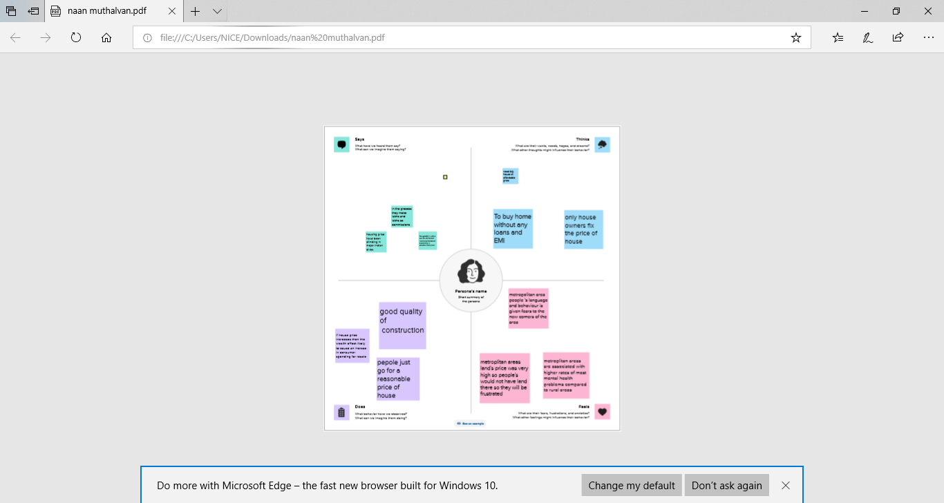

# 2.2 IDEATION AND BRAINSTORMING MAP

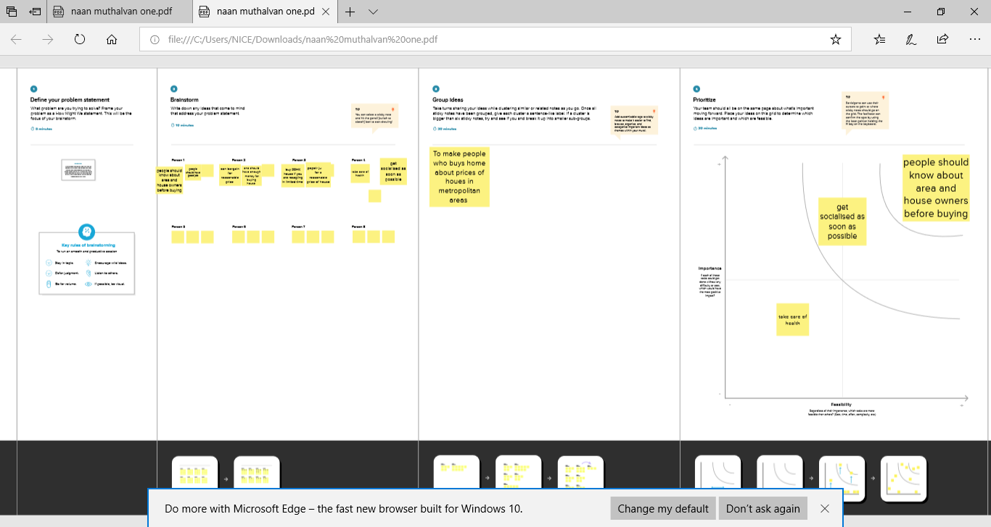

# 3. RESULT

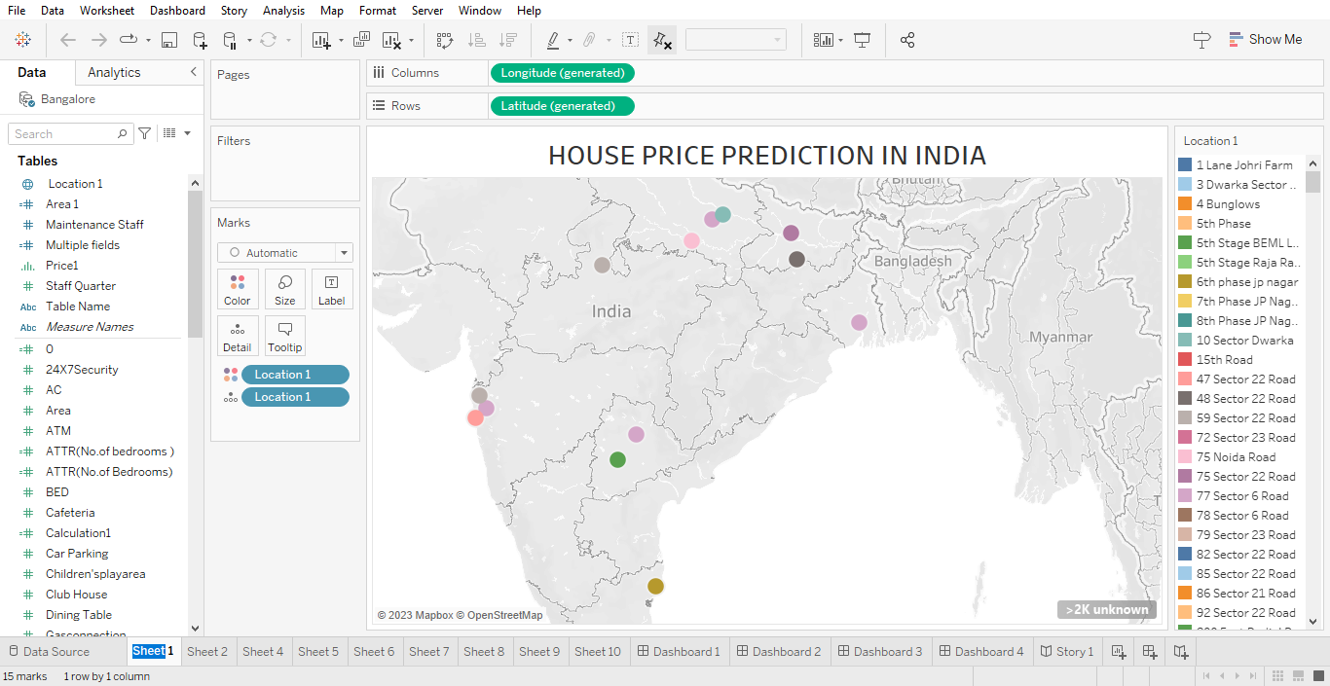

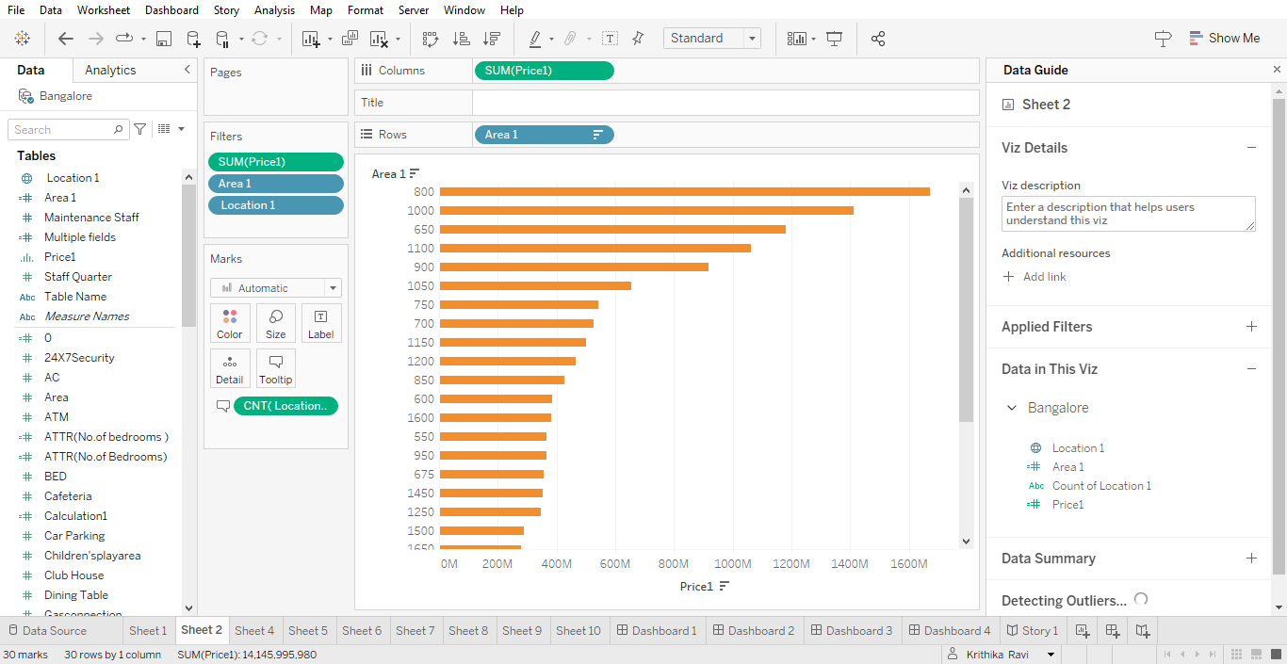

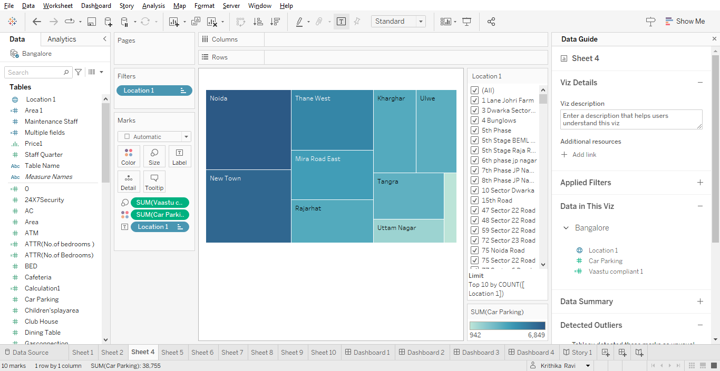

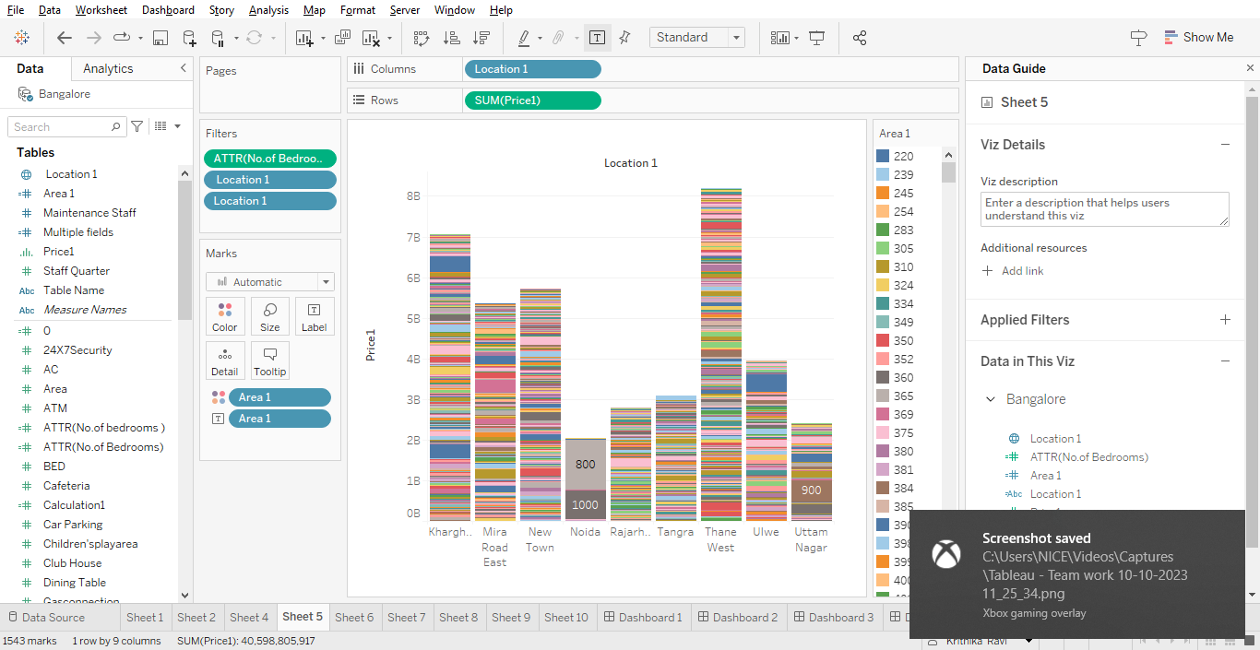

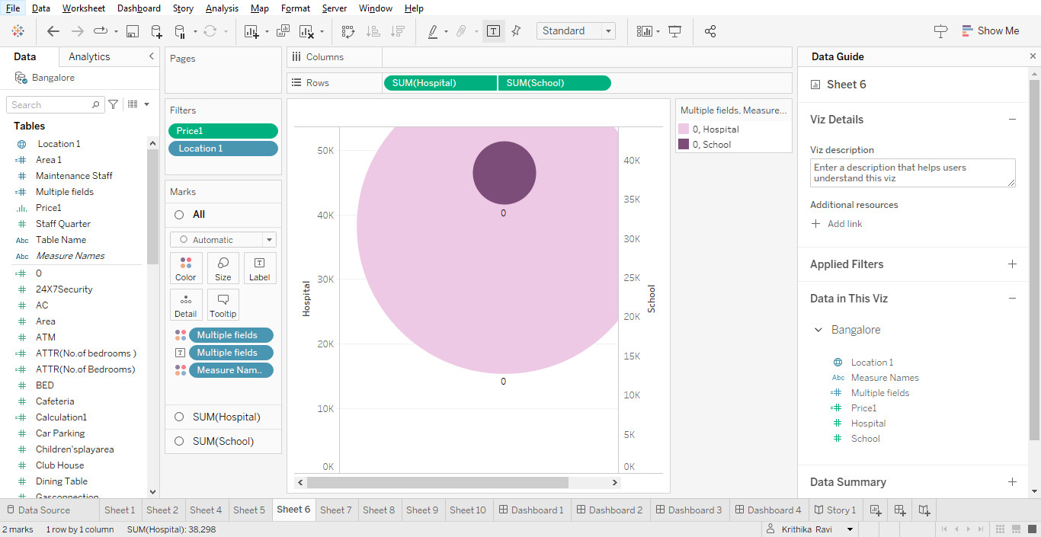

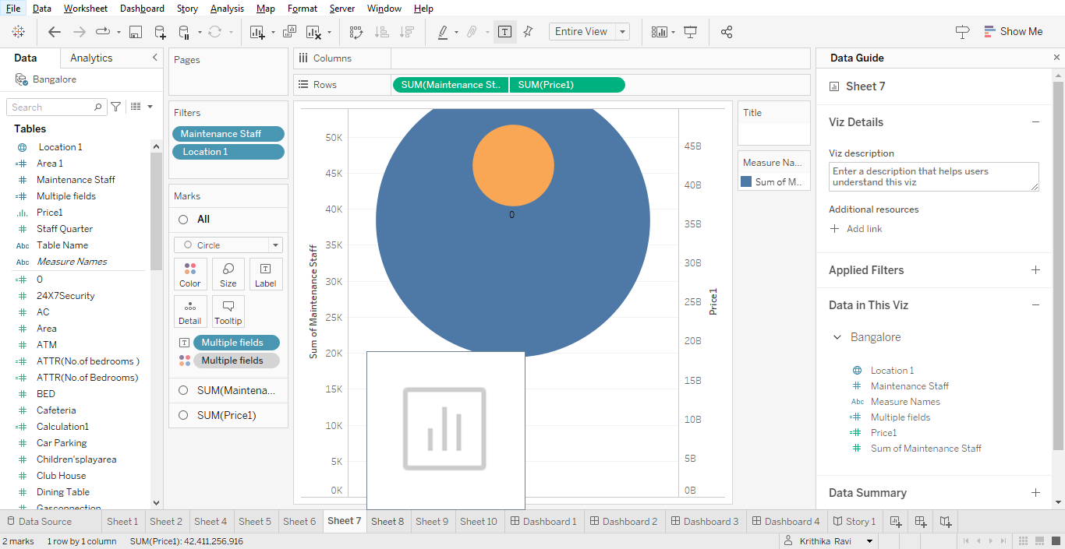

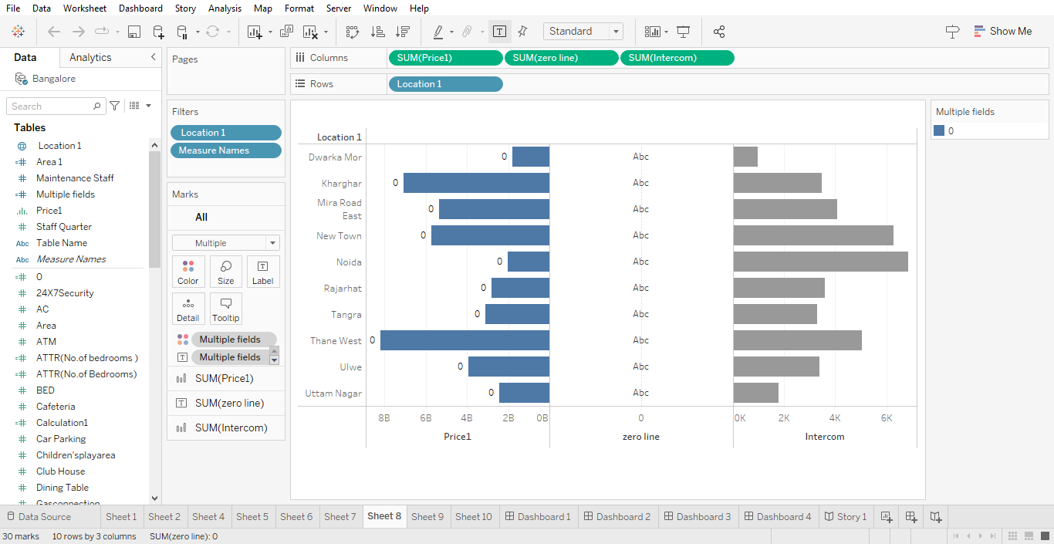

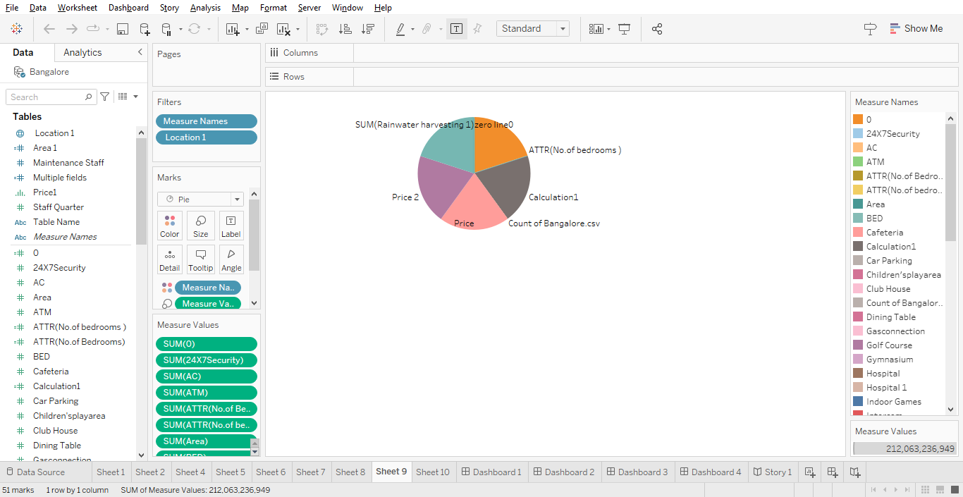

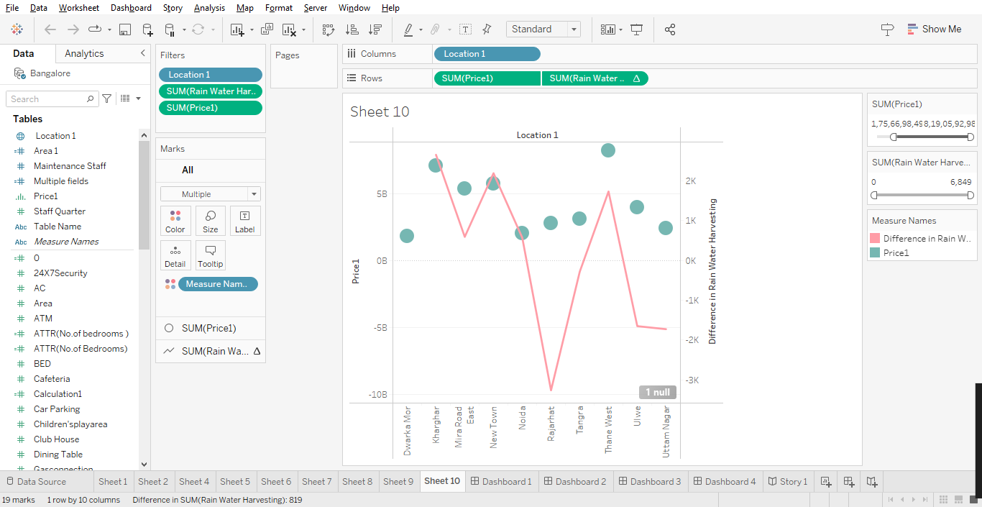

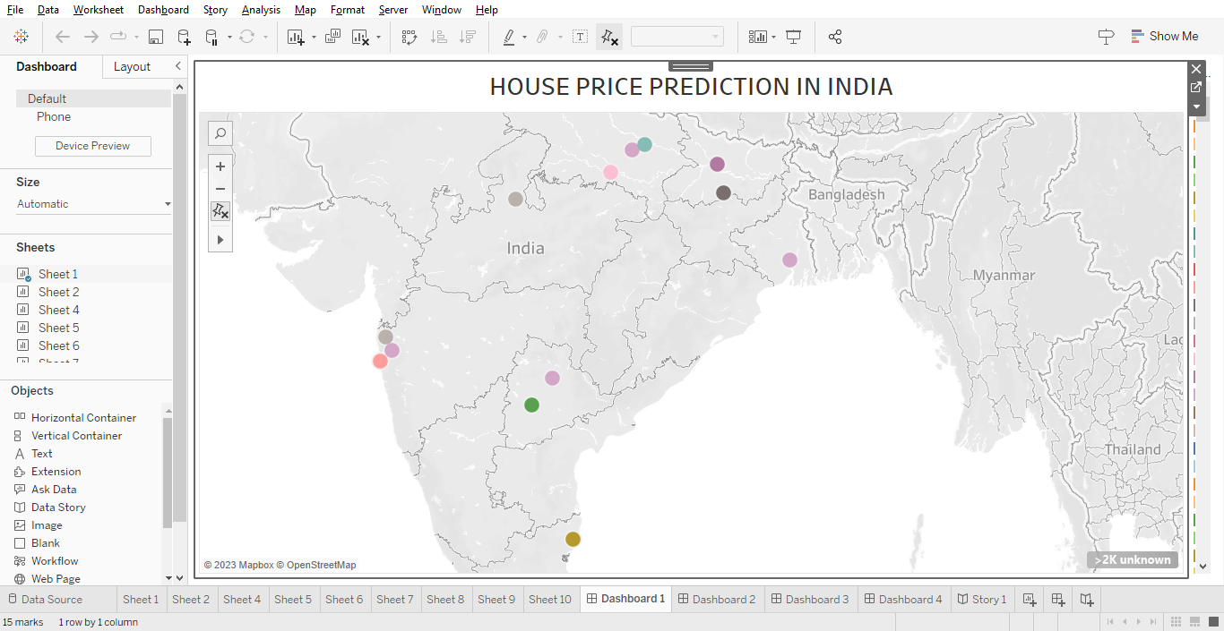

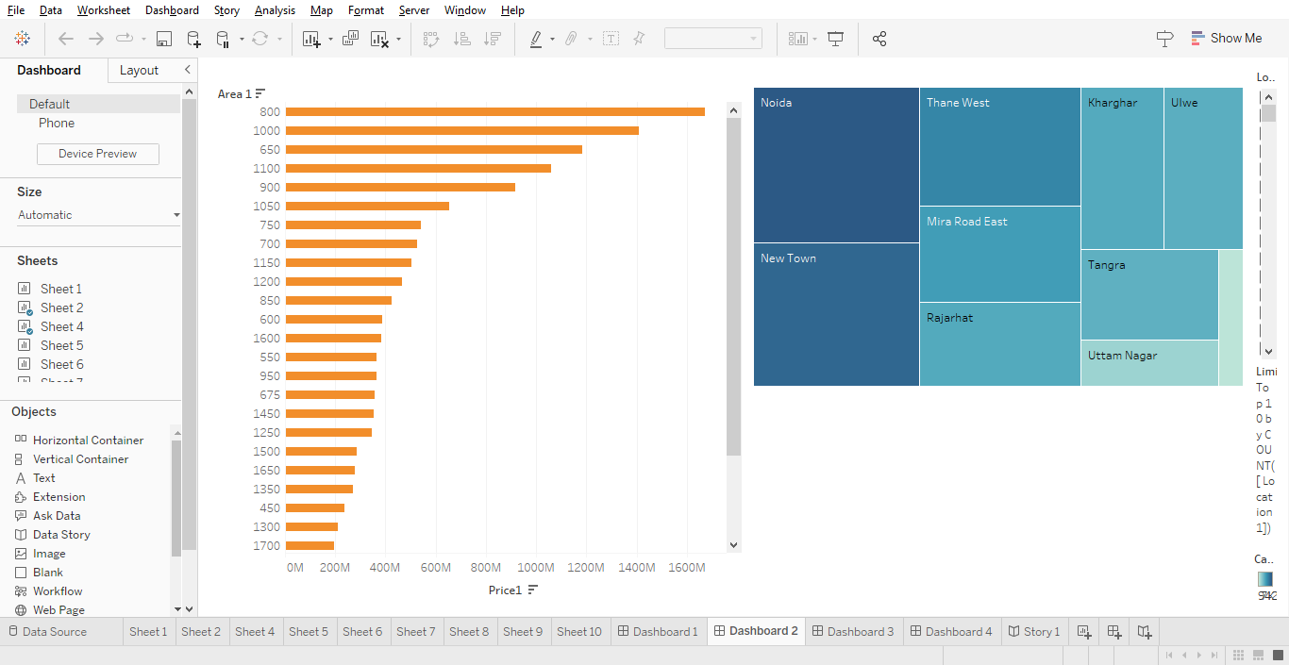

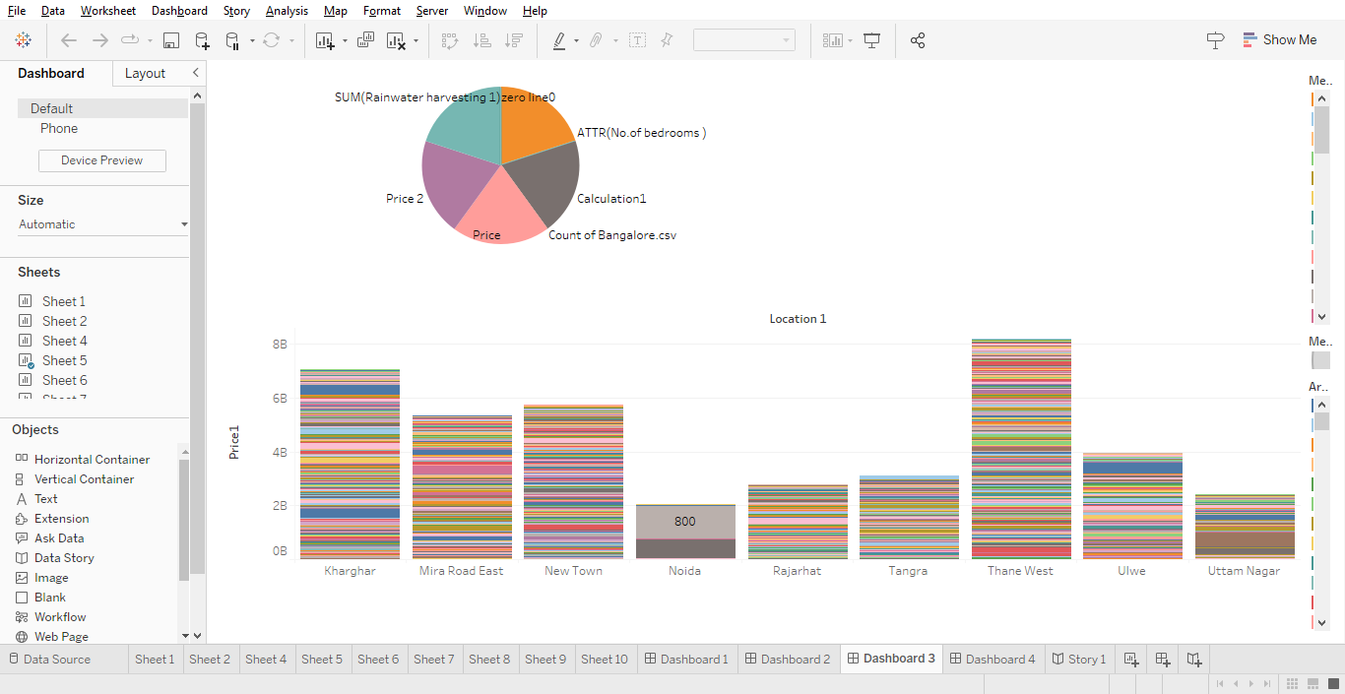

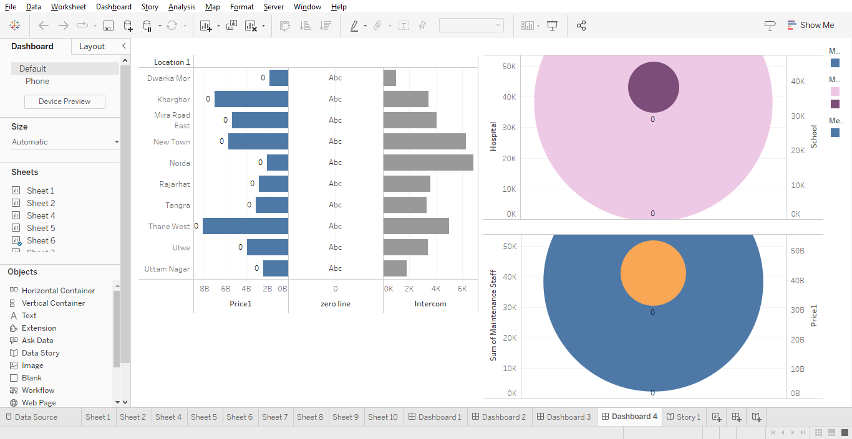

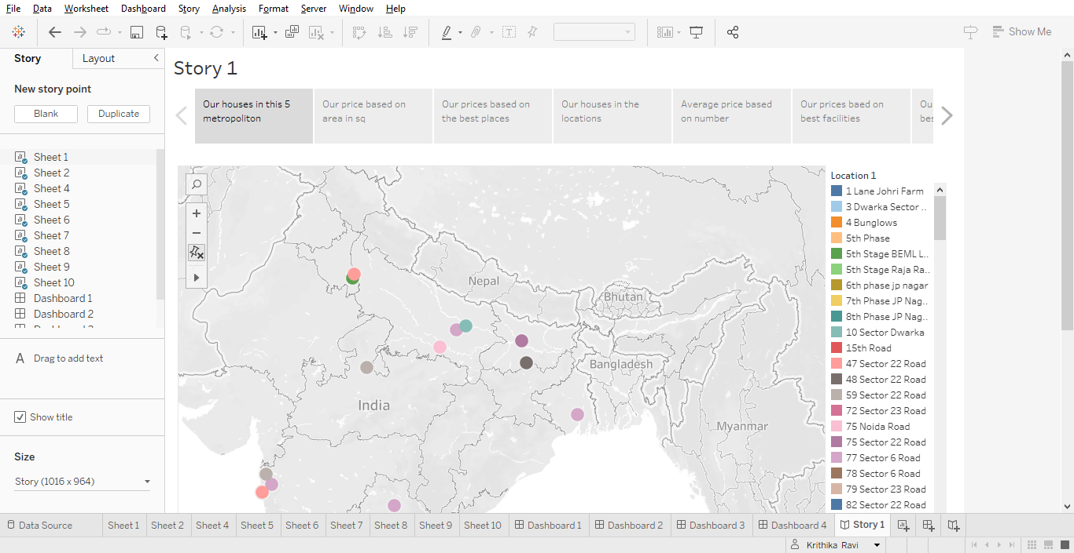

4. ADVANTAGES AND DISADVANTAGES

### ADVANTAGES.

*Easily trace hospitals , schools , parks nearby us.

* We can know about the house prices easily with affordable prices nearby areas.

* Presence of an transport facilities.

You can resale the house.

### DISADVANTAGES.

*High cost of rent in some areas.

* Over population.

5.APPLICATIONS.

House price prediction can help the developer determine this selling price of a house and can help the customer to arrange the right time to purchase a house.

6.CONCLUSION.

Based on the findings we come to a conclusion that first of all the cities are over populated than other areas. Many houses are sold and rent in metropolitan areas in affordable prices.

7.FUTURE SCOPE .

In India there is a high future scope for houses in metropolitan areas, because most of the companies , transport facilities are growing day by day. So there is high chance of building even more houses in metropolitan areas.